**Requirements - 1st Dec 2021**

**A. Challenge open for x (31)days > user accepts and has y (5)days to complete the total requirement (can be photo or steps) NON-Consecutive Days**

**-- 1Dec to 31st Dec - RANGE**

**-- 5th Dec - User Accepted  
 -- 31st Dec - Finish challenge  
 -- As challenge requirements completed e.g., 5 days in this case completed then - No access to that user**

**-acceptance period for 5 days and up to date should be less than (last date - challenge days{31-Dec – 5 Days}) user start date = challenge date when user accept the challenge and user last date= Challenge updto date + challenge days**

**User start date = when use accept challenge, accept date should be less then upto challenge date**

**User last date = user start date + challenge days   
B. Challenge open for x (31)days > user has Upto the Close Date to complete the total requirement (can be photo or steps) - CURRENT LOGIC  
 -- 1Dec to 31st Dec - RANGE**

**-- 5th Dec - User Accepted  
 -- No limitation to user access and uploads or steps until challenge date ends/closes**

**User start date = when use accept challenge**

**User last date = challenge Last date**

**C. Challenge open for x (31)days > user accepts and has y (5)days to complete the total requirement but must be completed in Consecutive Days (can be photo or steps)  
 -- 1Dec to 31st Dec - RANGE**

**-- 5th Dec - User Accepted  
 -- 10th Dec - Finish challenge  
 -- on 11th Dec - No access to that user**

**-acceptance period for 5 days and up to date should be less than (last date - challenge days{31-Dec – 5 Days}) user start date = challenge date when user accept the challenge and user last date= Challenge updto date – challenge days**

**With option a) the user can accept the challenge even if it is on the last day the challenge is open**

**With option c) the user cannot accept the challenge unless there are enough consecutive days left until the challenge closes**

**Notification pushes & emails will need to be updated so that they send to each user: at the beginning of the timed challenge, when the time limit of their challenge is 50% complete, at the end of their time limit**

**Modification to be done**

* Current challenge rule need to be replaced with rule of Challenge Activation from Date, Up to Date and no of days user will get to complete the challenge   
    
  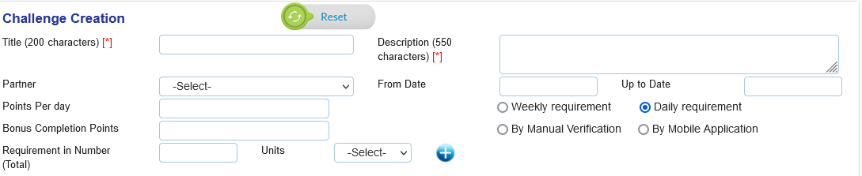
* New field for “**No of Days”** will be added & challenge activate when user accepts
* Here we will give three radio buttons with options e.g., **NON-Consecutive Days, Consecutive Days, Until the Close Date**
* When user accept the challenge, we need to take their **start date** and After that user **end date** will according to the user start date + no of days till challenge run (defined in backend)
* Impact and Rewards calculations will also be modified according to user **start date** and **end date**.
* All API to be modified according individual user start date and end date

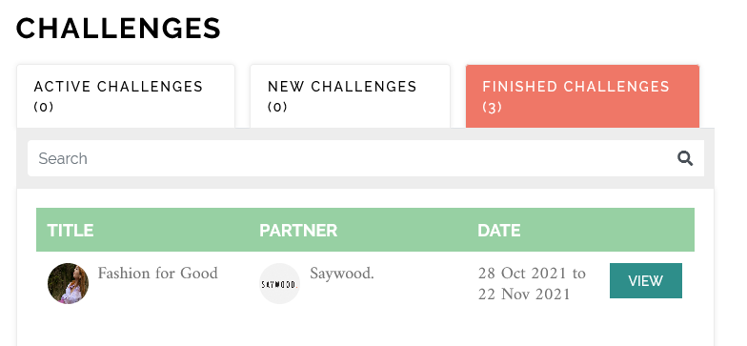

* Challenge date in finished challenge will also be modified
* Similarly for Active challenges
* Challenge listing excel report will also be modified
* Dashboard point calculations also corrected according to new rule

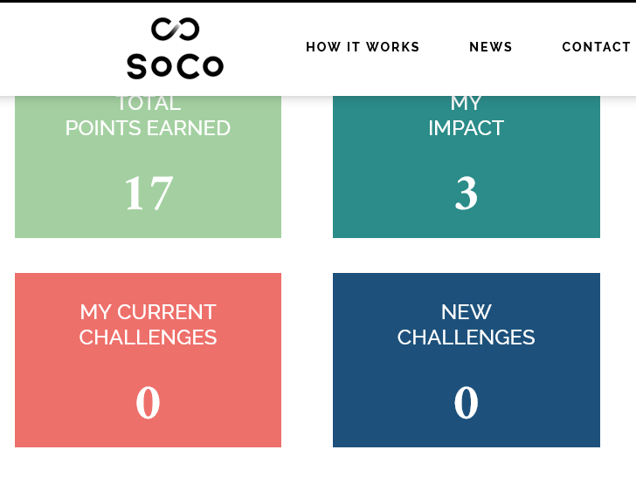

* All Emails and notification need to be recoded according to new rule

Thanks & Regards

Munish Ahuja