**API needs to be corrected**

API path needs to change to new domain todo.inqcrm.in

**BATCH CATEGORY LIST—API to be corrected according to sitewise as provided in image**

URL    : [http://coc.inqerp.com/api/v1/user/get\_total\_category\_wise\_task](http://coc.inqerp.com/api/v1/user/get_total_category_wise_task" \t "_blank)

METHOD : GET

INPUT PARAM : usercompcode, assignuser,tasktype

N-FOR PENDING,S->CLOSE,C->COMPLTED

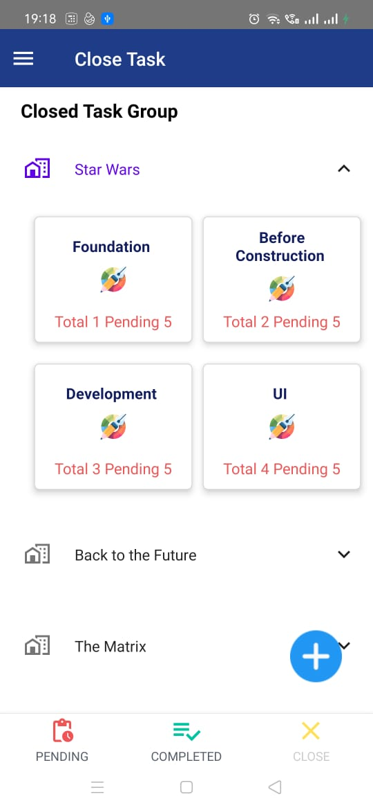

**CATEGORY WISE TASK LIST—API has to be corrected according to site and category selected**

URL    : [http://coc.inqerp.com/api/v1/user/get\_task\_list\_category\_wise](http://coc.inqerp.com/api/v1/user/get_task_list_category_wise" \t "_blank)

METHOD : GET

INPUT PARAM : usercompcode,category\_id,autherizedUserId,assigntaskstatus,processtask,tasktype

N-FOR PENDING,S->CLOSE,C->COMPLTED

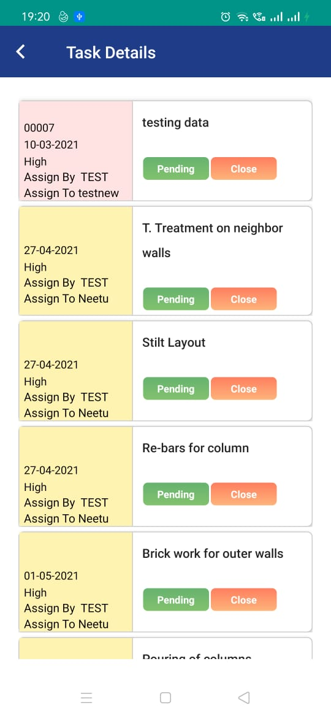

**NEW API required:**

1. For conversation.

2. Calender data

3. Posting pdf file while uploading in add task not working

4.Checklist api

5.Push notification